Project Design Phase-II
Technology Stack (Architecture & Stack)

Date | 14 Feb 2026
Team ID | LTVIP2026TMIDS52481
Project Name | Dog Breed Identification Using Transfer Learning
Maximum Marks | 4 Marks

Technical Architecture:
The system is a web-based deep learning application that classifies dog breeds from uploaded images.
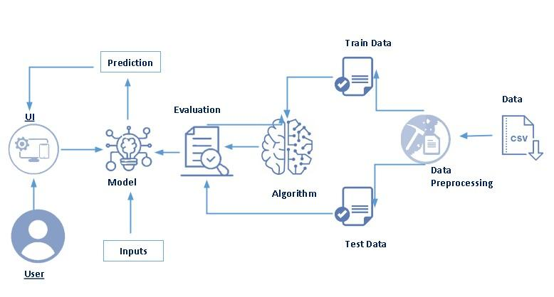

Flow:
User → Web UI → Flask Backend → MobileNetV2 Model → Prediction Result → Display on UI
Infrastructure
- Local training environment for model development
- Cloud deployment using Hugging Face Spaces for global access
- Image dataset stored locally during training and model weights stored for inference

Table-1 : Components & Technologies:
S.No | Component | Description | Technology
 | User Interface | Allows users to upload dog images and view predicted breed. | HTML, CSS, JavaScript
 | Application Logic-1 | Handles HTTP requests, image upload, and prediction routing. | Python, Flask
 | Application Logic-2 | Preprocesses images and feeds them to the trained deep learning model. | TensorFlow, NumPy, PIL
 | Database | Stores user login credentials for authentication. | SQLite
 | File Storage | Stores trained model file and uploaded images temporarily. | Local file system / Hugging Face storage
 | External API | Provides cloud hosting and model inference interface. | Hugging Face Spaces
 | Machine Learning Model | Classifies dog breeds using transfer learning. | MobileNetV2 (TensorFlow/Keras)
 | Infrastructure (Server / Cloud) | Training on local system and deployment on cloud. | Local: Python environment (VS Code / Jupyter)  Cloud: Hugging Face Spaces

Table-2: Application Characteristics:
S.No | Characteristics | Description | Technology
 | Open-Source Frameworks | Libraries used for ML training and web deployment. | TensorFlow, Keras, Flask, NumPy, Pandas
 | Security Implementations | User authentication and password protection. | By using flask we have created login page
 | Scalable Architecture | Separation of frontend, backend, and ML inference enables scalability. | Flask-based modular architecture, cloud deployment
 | Availability | Cloud hosting ensures global access and continuous availability. | Hugging Face Spaces hosting
 | Performance | Lightweight MobileNetV2 enables fast inference and low latency predictions. | TensorFlow optimized inference, image resizing preprocessing

References:
• https://www.kaggle.com/competitions/dog-breed-identification/data
• https://www.tensorflow.org/
• https://keras.io/api/applications/mobilenet/
• https://flask.palletsprojects.com/
• https://huggingface.co/docs/hub/spaces

